Rechargeable battery

This project uses 12V rechargeable battery. This project is much useful for industrial and Research Applications.

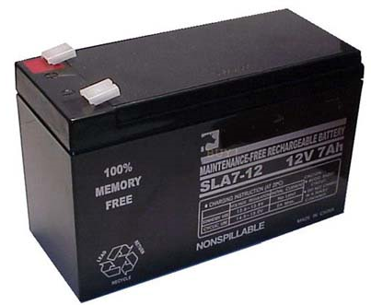

The Electrochemical Cell:

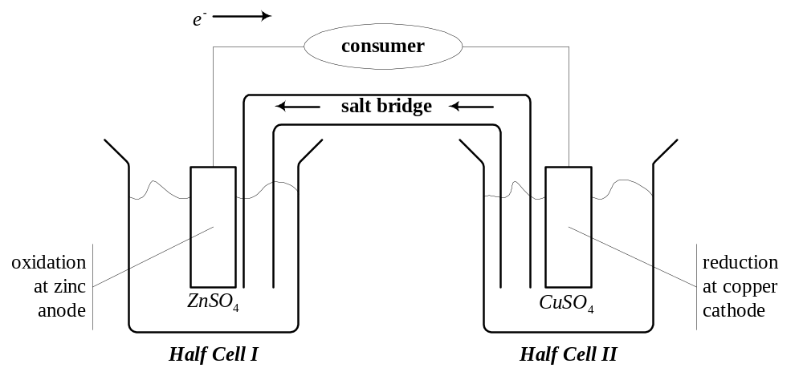

The Electrochemical Cell (2):

- Zinc is (much) more easily oxidized than Copper
- Maintain equilibrium electron densities
- Add copper ions in solution to Half Cell II
- Salt bridge only carries negative ions
- This is the limiting factor for current flow
- Pick a low-resistance bridge
Battery Characteristics:

- Size
  - Physical: button, AAA, AA, C, D...
  - Energy density (watts per kg or cm³)
- Longevity
  - Capacity (Ah, for drain of C/10 at 20°C)
  - Number of recharge cycles
- Discharge characteristics (voltage drop)
Further Characteristics
- Cost
- Behavioral factors
  - Temperature range (storage, operation)
  - Self discharge
  - Memory effect
- Environmental factors
  - Leakage, gassing, toxicity
  - Shock resistance

Primary (Disposable) Batteries:

- Zinc carbon (flashlights, toys)
- Heavy duty zinc chloride (radios, recorders)
- Alkaline (all of the above)
- Lithium (photoflash)
- Silver, mercury oxide (hearing aid, watches)
- Zinc air
- Chemistry

